Project Document 1: JavaTron

By: Edgar Diaz, Bhawna Gogna, Brianda Maldonado
CS 4800-005
04/30/2026

https://github.com/bmald0/cs4800-team2

Team Contributions
Team Member | Contribution
Brianda Maldonado | - Functional requirements  - Non-functional requirements  - User interface requirements  - Kept team meeting logs  - Package structure  - Class diagram  - Database ER diagram
Edgar Diaz | - Worked on document file  - Background description  - Problem description  - Equally contributed to Use Cases  - Equally contributed to Use Case diagram  - Solution description  - Worked on traceability matrix diagram
Bhawna Gogna | - Worked on Sequence Diagrams  - Created Player Connection & Matchmaking Sequence Diagram  - Created Full Gameplay Round Sequence Diagram  - Created Rematch Vote Flow Sequence Diagram  - • Created Player Disconnect Mid-Game Sequence Diagram  - Worked on interaction workflows in documentation  - Assisted in documenting server-client interaction process

Table of Contents
Section | Pg #
Team Meeting Log | 4
Background | 5
Problem | 5
Solution | 5
Use Case Overview | 6
Use Case Diagram | 6
Timeline | 6 - 7
System Requirements | 8
Functional Requirements | 8
Non-Functional Requirements | 7 - 8
User Interface Requirements | 8
Package Structure  Sequence Diagram | 8 – 10  10-14
Class Diagram | 14 – 18
Database ER Diagram | 19

Team Meeting Log
- Microsoft Teams – 04/21/26 at 3:30 pm – 4:30 pm
  - Attendees: Edgar, Brianda
- Discussed plan of action moving forward
- Discussed building on the current project
- Discussed ideas and additions to make for the project
- Discussed the addition of power-up functionality
- Discussed future meeting times
- Microsoft Teams – 04/29/26 at 6pm – 7pm
  - Attendees: Edgar, Brianda, Bhawna
- Discussed migrating the current project to a new repository
- Copied existing project to new repository
- Created document for first assignment
- Discussed the sections needed to complete the document
- Discussed the diagrams needed for the report
- Discussed dividing the sections of the report between team members


Edgar Diaz, Bhawna Gogna, Brianda Maldonado
Background
JavaTron is an online multiplayer light-cycle game inspired by the classic Tron concept, where players compete by moving around an arena and leaving trails behind them. The goal is to outmaneuver the opponent and avoid crashing into walls or trails. The game will include the core gameplay loop and online competition, making it a strong foundation for further development. Online multiplayer games are more engaging when they include competitive depth, replay value, and player interaction, JavaTron would benefit from additional gameplay features that improve the online experience.
Problem
Although JavaTron has a solid base concept, its current gameplay can become repetitive over time if every match plays out the same way. Since players are limited to the same movement and win conditions each round, there is less variety and strategic decision-making than there could be. For an online game especially, players are more likely to stay interested when there are features that make each match feel different and more competitive. Without these additions, the game may feel too simple compared to other multiplayer experiences.
Solution
To improve JavaTron, the project will focus on adding online gameplay features that increase strategy and excitement. One major improvement would be the introduction of power-ups that appear during matches and temporarily affect gameplay. Examples include a speed boost, which increases player speed for a short time, a slow opponent power-up, which reduces the other player’s speed, a shield that protects a player from one crash, and ghost mode, which allows a player to pass through trails briefly. These features would make each match less predictable and encourage players to make quick decisions based on timing and positioning.
In addition to power-ups, the game could also support online-focused quality of life features such as a rematch option, a leaderboard, and ranked matchmaking. A rematch option would allow two players to quickly start another game without returning to the lobby. A leaderboard would show the top players based on wins, losses, or rating. Ranked matchmaking would improve fairness by pairing players with others at similar skill levels. Together, these features would make JavaTron feel more polished and more like a complete online multiplayer game.

Use Case Overview
The main actor in this system is the Player, who can join an online match, play against another user, collect and use power-ups, request a rematch, and view rankings. The Game Server manages matchmaking, controls the match state, validates gameplay events, and records results. A Database stores player data, match history, and leaderboard statistics. The most important use cases include Join Match, Play Online Game, Collect Power-Up, Use Power-Up, View Leaderboard, Request Rematch, and Save Match Results. These use cases show how the system supports both the gameplay and the online competition features. 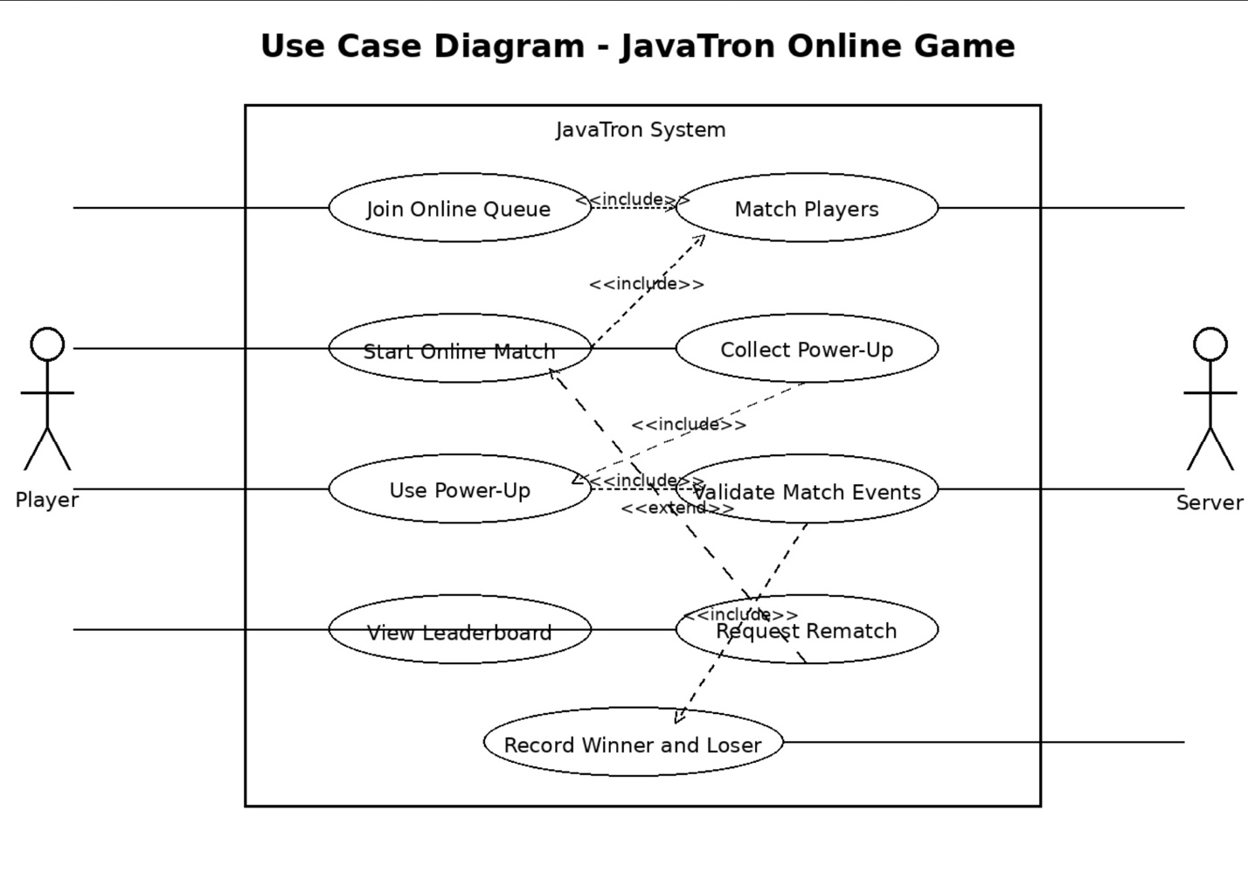
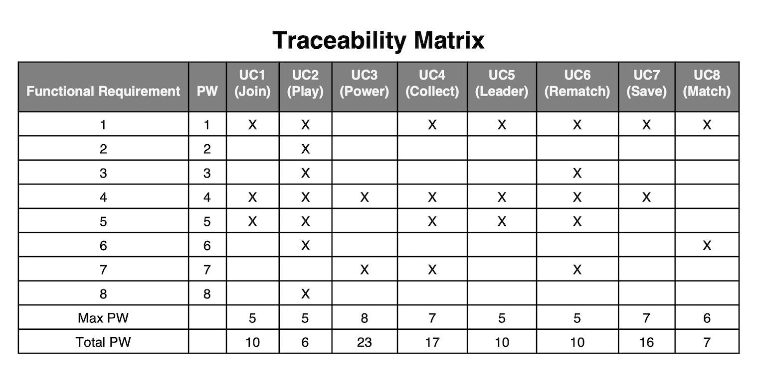
Timeline: Agile Scrum Model
Development of the new JavaTron features will follow the Agile Scrum model. Work will be divided into small feature-based sprints so that each improvement can be tested and integrated into the game step by step. Weekly scrum meetings will be used to discuss progress, challenges, and next steps. By using this model, the team can adjust features as needed and make sure the final version is both functional and enjoyable for players.
Sprint 1
Sprint 1 will focus on the backend and gameplay logic for online power-ups. During this sprint, the team will implement the spawning, collection, and activation of power-ups during matches. The server will need to validate when a power-up is collected and apply the correct gameplay effect to the player or opponent. This sprint will also include testing to make sure the new mechanics work correctly in online matches and stay synchronized between both players.
Sprint 2
It will focus on player experience and online features. This includes adding a rematch system, leaderboard functionality, and possibly a ranking or matchmaking system. The user interface will also be updated so players can clearly see power-ups, active effects, and post-match options. This sprint will help make the game feel more complete and polished while improving replay value and overall competitiveness.

System Requirements
- Functional Requirements
REQ -x | Requirement | Description
REQ-1 | Connect to server | Player enters IP and joins server
REQ-2 | Join lobby | Players enter matchmaking lobby
REQ-3 | Match players | Server pairs two players
REQ-4 | Start match | Server initializes match
REQ-5 | Control light cycle | Player moves using directional input
REQ-6 | Detect collisions | Server determines winner/loser
REQ-7 | Synchronize game state | Server updates clients in real time
REQ-8 | Record match results | Server stores match results in database
REQ-9 | Display leaderboard | System retrieves and displays rankings
REQ-10 | Rematch voting | Players vote for rematch
REQ-11 | Bot gameplay | Player can play against bot
REQ-12 | Ranked matchmaking | System groups players by skill level

- Non-Functional Requirements
NF-REQ-x | Requirement | Description
NF-REQ-1 | Performance | Real time gameplay with minimal delay
NF-REQ-2 | Scalability | Supports up to 20 concurrent players
NF-REQ-3 | Reliability | Handles disconnects safely
NF-REQ-4 | Consistency | Server maintains game state
NF-REQ-5 | Usability | Interface is simple and intuitive

- User Interface Requirements
UI-REQ-x | Requirement | Description
UI-REQ-1 | Main menu | Options for join server, settings, exit
UI-REQ-2 | Lobby screen | Displays players and match status
UI-REQ-3 | Game screen | Displays arena and gameplay
UI-REQ-4 | Results screen | Shows winner and match outcome
UI-REQ-5 | Leaderboard screen | Displays player rankings

Package Structure
Package | Classes | Responsibility
edu.csu.javatron | JavaTronGame,  FirstScreen,  MainMenuScreen,  ConnectScreen,  LobbyScreen,  GameScreen,  RematchVoteScreen,  SettingsScreen | Central client program flow, handles screen transitions and primary user-facing game interface.
edu.csu.javatron.client.net | NetworkClient,  Protocol,  ServerMsgType | Client-side networking, protocol constants, server message packet parsing and outbound packet request handling.
edu.csu.javatron.client.input | InputController,  Settings | Receives player controls, manages key remapping, stores client-side settings.
edu.csu.javatron.client.model | Arena,  CycleState,  MatchState,  TrailGrid | Manages client-side gameplay state for rendering and sync with server snapshots.
edu.csu.javatron.server | ServerMain,  ServerConfig,  StatsManager | Starts server, loads settings, handles runtime settings, logging and player statistics.
edu.csu.javatron.server.lobby,  edu.csu.javatron.server.match,  edu.csu.javatron.server.net,  edu.csu.javatron.server.player | LobbyManager,  MatchMaker,  MatchRoom,  MatchRules,  MatchState,  TrailGrid,  RematchVoteManager,  ServerTransport,  ClientSession,  SnapshotSerializer,  Protocol,  PlayerProfile,  ColorResolver | Handles matchmaking, authoritative gameplay simulation, TCP communication, player session states, distributes snapshot packets, holds player data (such as colors, IP).

Sequence Diagram
- Player Connects & Matchmaking
- Player inputs server IP and port then clicks connect
- Client initiates TCP connection to server
- The server receives the connection and transmits S_WELCOME.
- The client transmits C_HELLO (name + color)
- Client initiates C_FIND_MATCH request
- Server places player in matchmaking queue.
- Server transmits S_LOBBY_STATUS (pending state)
- The second player enters and submits a match request.
- LobbyManager removes both players from the queue.
- Server establishes MatchRoom (game session thread)
- Server transmits S_MATCH_FOUND to each player
- Server transmits S_MATCH_START
- Both clients transition from the lobby to the game interface.
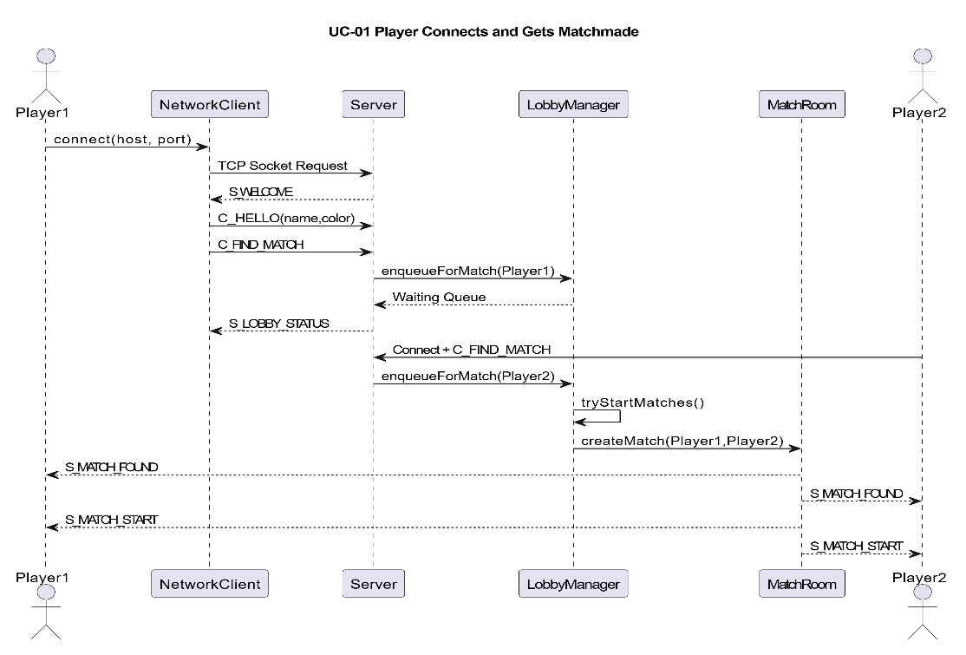

- Full Gameplay Round
- Server transmits countdown (3 → 2 → 1 → START)
- Participants submit C_TURN commands (directions)
- Server executes game loop at 60 ticks per second
- Inputs are gathered and utilized every tick.
- Server calculates the upcoming moves for both players at the same time.
- Server verifies collisions through TrailGrid
- If there’s no collision → adjust positions and paths
- The server transmits S_SNAPSHOT (game state) to each player.
- Loop persists through each tick
- If a collision happens → figure out outcome
- Server refreshes score
- Server reinitializes round status.
- Server transmits S_ROUND_END (victor + points)
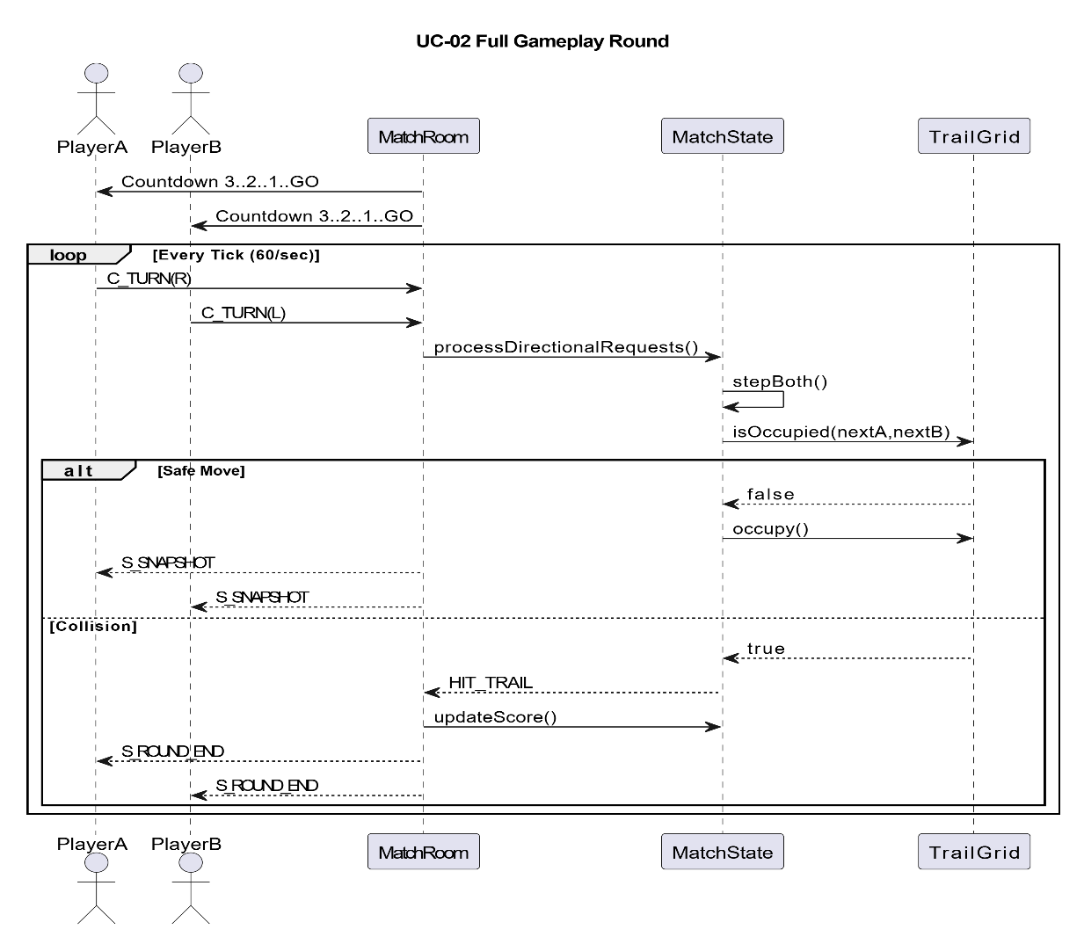

- Player Disconnect Mid-Game
- Player abruptly exits the game (no disconnection message)
- Server heartbeat identifies absent reply
- Server identifies player session as disconnected
- MatchRoom identifies disconnection
- Server announces the other player as the winner (forfeit)
- Database matches server updates for results
- Server halts game loop / sound
- Server transmits S_MATCH_END to the other player
- Server transmits S_RETURN_TO_LOBBY
- Server eliminates session of disconnected player
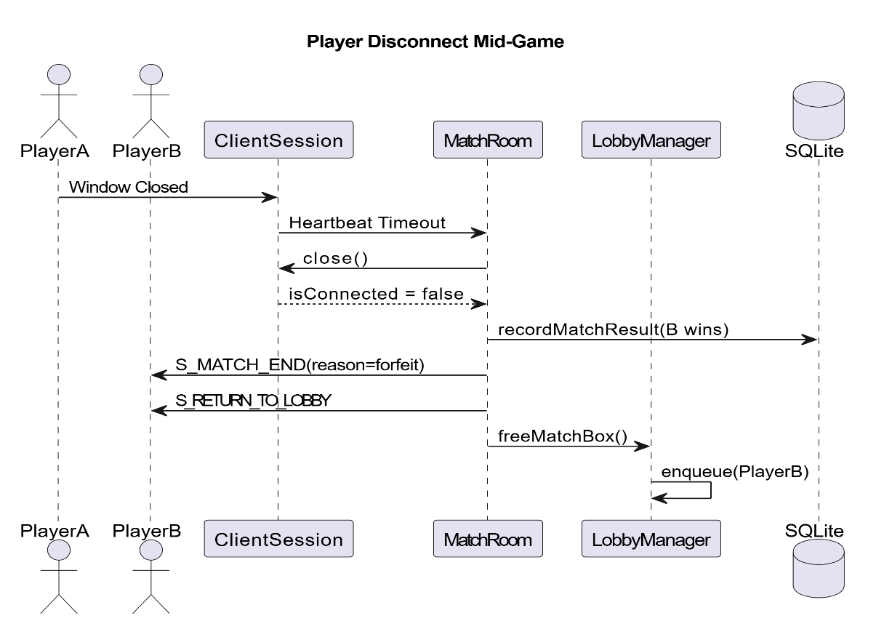

- Rematch Vote Flow (Workflow)
- After the match concludes, the server transmits S_MATCH_END.
- Server initiates a 30-second voting countdown
- The server transmits S_REMATCH_PROMPT to each player.
- Participants select YES or NO
- Participants submit C_REMATCH_VOTE
- Server gathers both votes
- Decision paths:
  - If both are YES → initiate new match (S_MATCH_START)
  - If a single NO → NO player leaves, the YES player goes back to the lobby.
  - If neither option is selected → both return to title screen
  - If timeout occurs → considered as NO → go back to lobby.
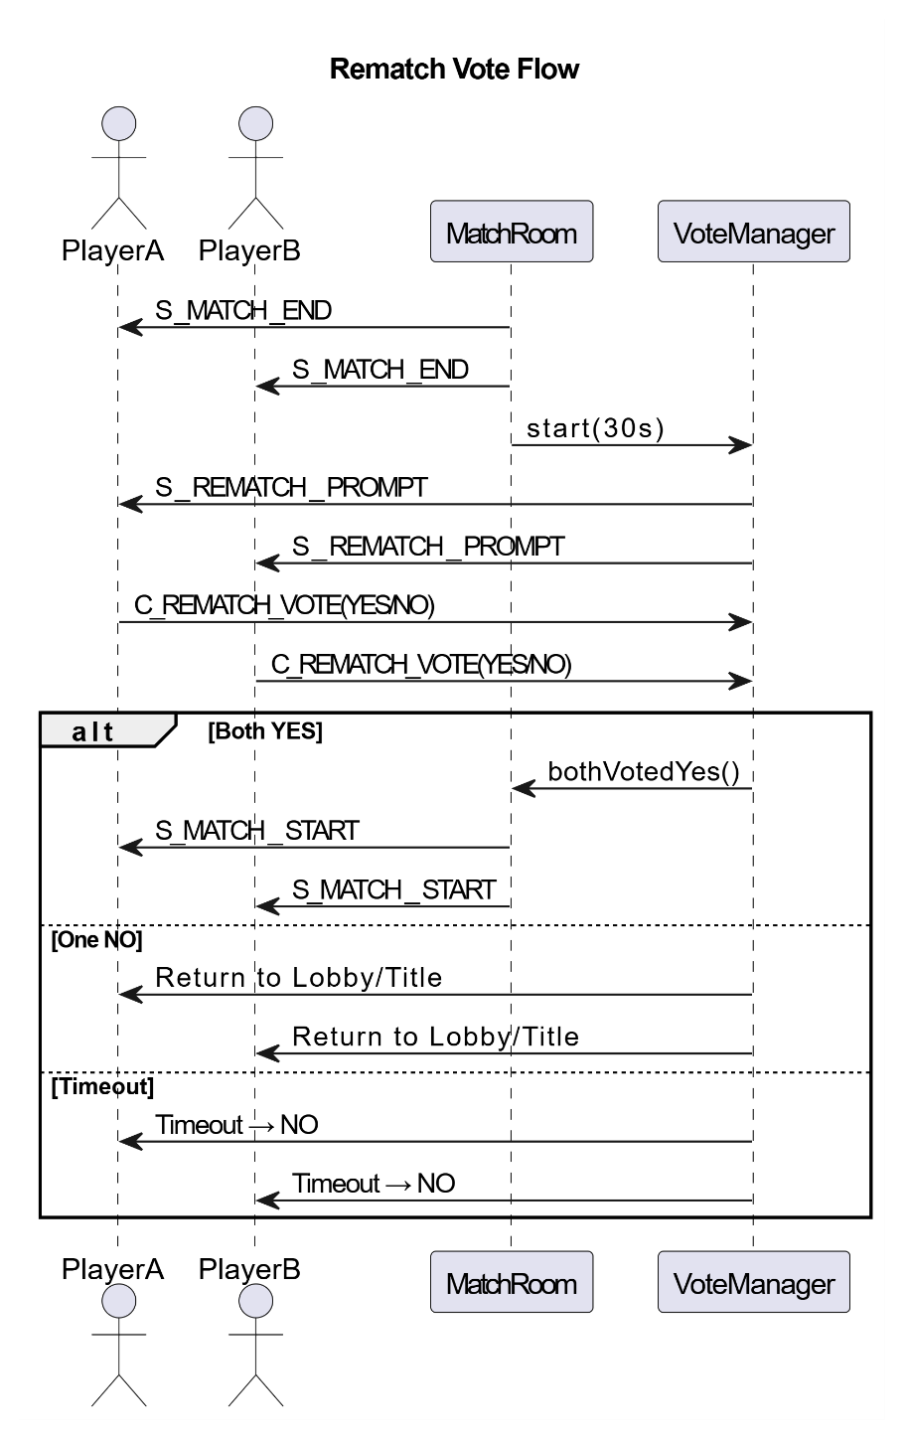

Class Diagram
JavaTronGame
- Create(): void – Initializes the shared client state, audio resources and user configuration, network wrapper and displays the main menu to user.
- UpdateSnapshot(ax, ay, bx, by, aDir, bDir, aWins, bWins, roundnumber): void – Stores the most recent match snapshot transmitted by the server, which tells the client the present positions and info of each player (designated A and B).
- ShowMainMenu(), showConnectScreen(), showLobbyScreen(), showGameScreen(), showRematchVoteScreen(), showSettingsScreen(): void – Handles switching between different screens of the client menu, such as settings or connection menu.
- HandleServerConnectionLost(): void – Resets client state and returns to menu if connection to server is lost.
- Render(): void - Executes the LibGDX render loop and sends heartbeat ping traffic to server to maintain connection.
- Dispose(): void – Frees up audio and shared client resources when program is terminated.
NetworkClient
- Connect(host: String, port: int): void – Establishes a TCP socket to server and begins background listener thread.
- Send(line: String): void – Sends a packet message to the server.
- Listen(): void – Continuously reads packets from server and routes to message handler.
- HandleMessage(message: String): void – Processes packets such as S_WELCOME, S_MATCH_FOUND, S_MATCH_START, S_SNAPSHOT, S_MATCH_END, and S_LOBBY_STATUS.
- ParseSnapshot(message: String): void – Extract coordinates, directions, score and round number from S_SNAPSHOT packets.
- HandleConnectionLost(): void – Cleans socket listener and notifies user that connection was lost.
ServerMain
- Main(args: String[]): void – Boots server, loads server.cfg, configures logging, starts lobby manager and server transport. If ran with GUI, opens GUI window.
- FormatLine(msg: String): String – Formats server log lines with timestamps.
- LogFileSink.create(...): LogFileSink – Creates either timestamped individual or single-file persistent (depending on server operator configuration) server logs.
- DiscordWebhookSink.create(...): DiscordWebhookSink – Optionally enables webhook-based relay of server log events. Not enabled by default.
- ServerGui.appendLog(line: String): void – Adds new log output to GUI console.
- ServerGui.setPlayers(lines: List<String>): void - Refreshes GUI player list on left side of server GUI window.
ServerConfig
- LoadOrCreate(configPath, logger): ServerConfig – Loads / creates server config.
- WriteDefault(configPath, cfg): void – Writes default config values into new server.cfg
- AppendMissingKeys(configPath, existing, defaults): void – If any configurable variables are missing from server.cfg, adds them to the file.
- ParseKeyValueFile(path: Map<String, String> - Reads the server..cfg key-value format.
- ParseInt(...), parseBool(...), clamp(...): helper methods - Validates and constrains configuration values as defined by server config.
LobbyManager
- OnClientConnected(socket: Socket): void – Creates a new client session, assigns a player identifier, and adds player to the lobby system.
- HandleClientLine(session, line): Void – Parses incoming client packets such as C_HELLO, C_FIND_MATCH, C_TURN, C_REMATCH_VOTE and C_PING.
- EnqueueForHumanMatch(Session): void – Places eligible players into matchmaking queue.
- TryStartMatches(): void - Pulls queued players and assigns them into a free box when possible.
- StartMatchPvp(box, a, b): void – Creates and starts a new MatchRoom thread for two players.
- OnMatchEnded(box, result): void – Cleans up lobby state after a match ends and returns them to proper post-match state.
MatchRoom
- Start(): void – Starts dedicated thread for one active match box.
- RunLoop(): void – Executes fixed-tick rate gameplay loop, such as countdowns, collisions, voting, disconnect handling and match progression.
- OnClientTurn(who, dir): void – Accepts directional input request from client and stores it for next authoritative tick.
- HandleRoundEnd(res: StepResult): void – Determines round winer or draw, updates scores, checks if full match has ended.
- RunCountDown(): void – Sends pre-round countdown to both player clients.
MatchState
- Reset(): void – Clears the arena and restores the default spawn positions for a new round.
- ResetWithSpawns(...): void – Resets arena with custom spawn positions, specifically used for draw-resolution cases (adjusting player starts to avoid immediate head-on collision if neither player immediately moves).
- StepBoth(dax, day, dbx, dby, nowMillis): StepResult – Advances both players simultaneously, applies trail placement, and evaluates wall/trail collisions.
- StepResult.anyCollision(): boolean – Reports whether either player collided during current step.
TrailGrid
- Clear(): void – Removes all occupied trail cells from current round (blank slate for new rounds)
- IsInside(x, y): boolean - Checks whether a coordinate is within the arena bounds.
- IsOccupied(x, y): boolean - Checks if a trail already exists at the given cell.
- DecayIfNeeded(trailTimeSeconds, nowMillis)L void – If server operator enables trail expiration, removes expired trail cells.
ClientSession
- SendLine(line: String): void – Sends one packet message to connected client.
- ReadLine(): String – Reads next client packet from socket and updates heartbeat timing (otherwise kick idle clients)
- SetRequestedColor(...), setPlayerName(...), setActiveColor(...): void – Stores player identity and color data for each lobby and match use.
- SetPendingTurn(dir: char): void – Stores client’s most recent directional input request.
- GetDisplayColor(): String – Returns color that should be shown to player.
- Close(): void – Closes network session and marks client as disconnected.
ServerTransport
- Start(port: int): void – Starts the background accept loop for incoming TCP connections.
- RunAcceptLoop(): void – Opens the ServerSocket, accepts new clients, and routes them to the lobby manager.
- Shutdown(): void – Closes listening socket, stops accepting new connections.
RematchVoteManager
- Start(nowMillis, timeoutMillis): void – Begins rematch voting window after match ends.
- Vote(who, yes): void – Records a player’s “Yes” or “No” vote.
- BothVotedYes(): boolean – Returns whether both players agree to rematch.
- AnyVotedNo(): boolean – If one player rejects, no rematch.
- TimedOut(nowMillis): boolean – Determines whether rematch vote timer has expired.
- End(): void – Ends voting phase.
StatsManager
- registerPlayerSession(session): void – Ensures a leaderboard record exists for a connected player
- recordMatchResult(winner, loser): void – Updates win/loss totals, recalculates win rate, and records unique derezzes after a completed match
- getTopLeaderboardEntries(limit): List<LeaderboardEntry> - Returns leaderboard records for display in the client lobby
- Initalize(): void – Connects to SQLite and creates required tables if missing

Database ER Diagram
